**Program no____5_____**

**Program Title_____Temperature sensor________**

**Aim Converts degree in Celsius to Fahrenheit**

**Hardware Required**

* Arduino Board

Temperature sensor(TM36)

**Circuit Diagram**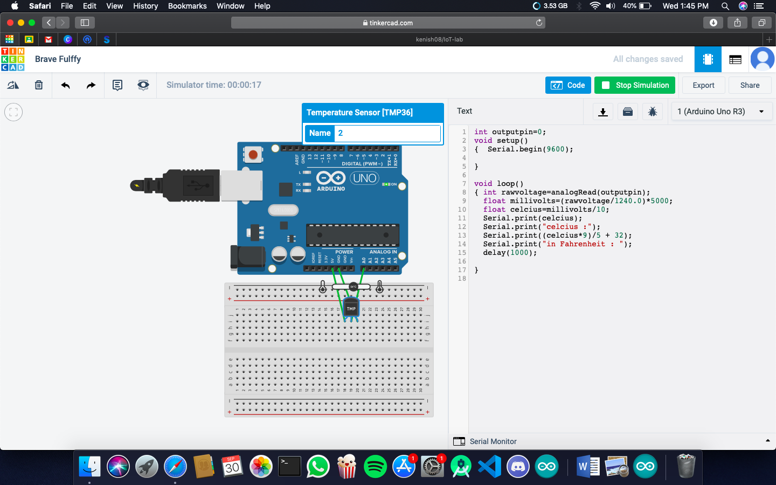

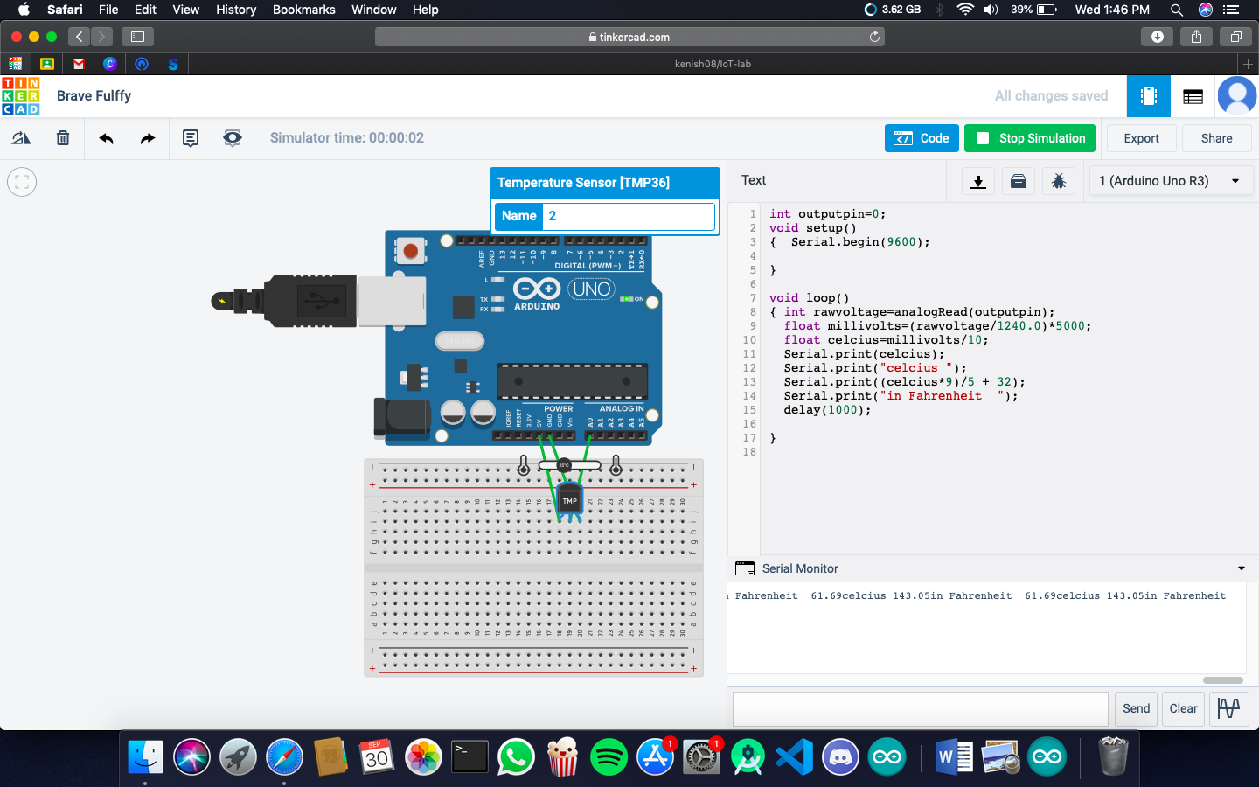

**CODE:**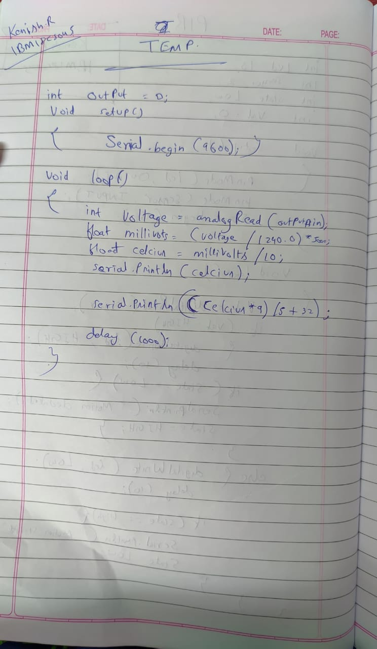

**Observation /Output**

**converts degree in Celsius to Fahrenheit**